Watch For Me NC 2014 Overview and

Pedestrian and Bicycle Crash Facts

Overview
North Carolina routinely ranks as one of the most dangerous places for pedestrians and bicyclists. Each year, roughly 2,600 pedestrians and 970 bicyclists are hit by cars in NC, with about 168 pedestrian and 22 bicycle fatalities per year. These figures represent only police-reported crashes that make it through the DMV system. Past studies have estimate that police-reported crashes represent only about 56 percent of pedestrian and bicyclist incidents that occur.
Watch for Me NC is a comprehensive education and enforcement campaign aimed at reducing the number of pedestrians and bicyclists hit and injured in crashes with vehicles. The program is a collaborative effort with state and local transportation agencies and consists of outreach strategies, such as radio and transit advertisements, and law enforcement to educate all road users on safe behaviors and laws.
The following statistics were compiled by the University of North Carolina’s Highway Safety Research Center, analyzing statewide pedestrian and bicycle crashes reported by police from 2008 to 2012.

Who is most often involved in pedestrian and bicyclist crashes?
- Male bicyclists account for about 85% of the crash-involved bicyclists and for 60% of the pedestrian-vehicle crashes in North Carolina.
- On average, drivers age 25 and younger accounted for more than 23% of all collisions with bicyclists and 24% of all collisions with pedestrians.
- More than 50 percent of all crashes involved bicyclists under the age of 30. Pedestrian crashes more typically involved the adult population, aged 18 to 60 (see charts below).
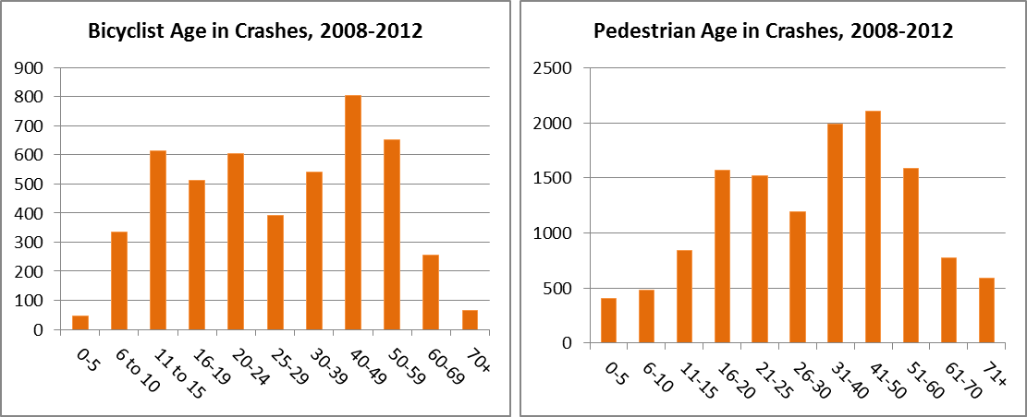

Where do pedestrians and bicyclists collisions occur?
- About 25% of vehicle-pedestrian crashes happen at or near an intersection. Another 30% occur at a non-roadway location such as parking lots. The most common location of pedestrian crashes (45%) is at non-intersection locations, such as at midblock crossings or driveways.
- About half of all vehicle-bicyclist crashes occurred at intersections or were intersection-related. Only 5% of crashes involved a bicyclist in a bike lane at the time of the crash; in 66% of the crashes the bicyclist was in the travel lane.
- 22% of all bicyclists hit were riding against traffic at the time of the crash. In terms of location, 16% of cyclists hit were on the sidewalk or in a crosswalk. Riding against traffic, even when on the sidewalk, can be a serious safety problem as it puts cyclists where motorists do not expect them, particularly at driveways and at intersections where drivers may be scanning for traffic only to the left before pulling out.

When are crashes happening?
- October is the peak crash month for pedestrians, while May is the peak crash month for bicyclists. About 54 percent of bike collisions occur between May and September.
- For both pedestrians and bicyclists, crashes occur more often on weekdays than weekends.
- Half of all bicycle collisions (50%) and 40% of all pedestrian collisions occur between the mid-afternoon to evening hours of 3 to 9 pm, which covers the span of peak afternoon commute times.
What are the most common types of crashes?
Top 10 most frequent NC pedestrian crash types (grouped), 2008-2012
Rank | Grouped Pedestrian Crash Type | Total | Percent of NC Total
1 | Crossing Roadway (vehicle turning or going straight) | 3349 | 25.4%
2 | Unusual Circumstances or Rare Events (including disputes, unique midblock, crossing expressways, waiting to cross, unknown, etc.) | 2970 | 22.5%
3 | Off Roadway (e.g., parking lots) | 1726 | 13.1%
4 | Backing Vehicle | 1423 | 10.8%
5 | Walking Along Roadway | 1245 | 9.4%
6 | Pedestrian in Roadway (working, playing, or circumstances unknown) | 1074 | 8.1%
7 | Dash / Dart-Out | 876 | 6.6%
8 | Crossing Driveway or Alley | 233 | 1.8%
9 | Multiple Threat / Trapped | 169 | 1.3%
10 | Bus-Related | 121 | 0.9%
 | Total | 13,186 | 100.0%

Top 10 most frequent NC bicycle crash types (grouped), 2008-2012
Rank | Grouped Bicyclist Crash Type | Total | Percent of NC Total
1 | Motorist Overtaking Bicyclist (undetected bicyclist, misjudged space, unknown reason) | 937 | 19.2%
2 | Motorist Left or Right Turn / Merge | 654 | 13.4%
3 | Motorist Failed to Yield - Sign- or Signal Controlled Intersection | 648 | 13.3%
4 | Other / Unusual / Rare / Unknown | 593 | 12.1%
5 | Bicyclist Left or Right Turn / Merge / Turning Error | 557 | 11.4%
6 | Bicyclist Failed to Yield - Sign- or Signal Controlled Intersection | 511 | 10.5%
7 | Motorist Failed to Yield - Midblock | 319 | 6.5%
8 | Bicyclist Failed to Yield - Midblock | 305 | 6.2%
9 | Non-Roadway (e.g., parking lot) or Backing Vehicle | 236 | 4.8%
10 | Head-On | 129 | 2.6%
 | Total | 4,889 | 100.0%

Source: Pedestrian and Bicycle Crash Analysis Tool (PBCAT), a national system for coding pedestrian and bicycle crashes using police reports describing pre-crash events and movements.

Additional Resources
For descriptions and more information on common crash types, and instructions on how to apply the Pedestrian and Bicycle Crash Analysis Tool (PBCAT) to your data, visit: http://www.pedbikeinfo.org/pbcat_us/.
For general information, program materials, and other resources, visit: www.watchformenc.org.
For access to statewide pedestrian and bicycle crash data, visit: http://www.pedbikeinfo.org/pbcat_nc/.

